**Name:** Dhairya Patil **Class:** TY-15 (Batch C) **Roll Number:** 2223929

ECL Experiment 8

## Introduction

**The "magic wand" project that can recognize gestures using an accelerometer and an ML classification model on Edge Devices**

**Objective:** Build a project to detect the accelerometer values and convert them into gestures

**Tasks:**

* Generate the dataset for Accelerometer Motion (Up-Down, Left-Right)
* Configure BLE Sense / Mobile for Edge Impulse
* Building and Training a Model
* Deploy on Nano BLE Sense / Mobile Phone

## Introduction

Edge Impulse is a development platform for machine learning on edge devices, targeted at developers who want to create intelligent device solutions. The " Accelerometer Motion "sensor reading equivalent in Edge Impulse would typically involve creating a simple machine learning model that can run on an edge device, like classifying sensor data or recognizing a basic pattern.

## Materials Required

* Nano BLE Sense Board

## Theory

GPIO (General Purpose Input/Output) pins on the Raspberry Pi are used for interfacing with other electronic components. BCM numbering refers to the pin numbers in the Broadcom SOC channel, which is a more consistent way to refer to the GPIO pins across different versions of the

Here’s a high-level overview of steps you'd follow to create a "Hello World" project on Edge Impulse:

**Steps to Configure the Edge Impulse:**

1. Create an Account and New Project:

* Sign up for an Edge Impulse account.
* Create a new project from the dashboard.

1. Connect a Device:

* You can use a supported development board or your smartphone as a sensor device.
* Follow the instructions to connect your device to your Edge Impulse project.

1. Collect Data:

* Use the Edge Impulse mobile app or the Web interface to collect data from the onboard sensors.
* For a "Hello World" project, you could collect accelerometer data, for instance.

1. Create an Impulse:

* Go to the 'Create impulse' page.
* Add a processing block (e.g., time-series data) and a learning block (e.g., classification).
* Save the impulse, which defines the machine learning pipeline.

1. Design a Neural Network:

* Navigate to the 'NN Classifier' under the 'Learning blocks'.
* Design a simple neural network. Edge Impulse provides a default architecture that works well for most basic tasks.

1. Train the Model:

* Click on the 'Start training' button to train your machine learning model with the collected data.

1. Test the Model:

* Once the model is trained, you can test its performance with new data in the 'Model Testing' tab.

1. Deploy the Model:

* Go to the 'Deployment' tab.
* Select the deployment method that suits your edge device (e.g., Arduino library, WebAssembly, container, etc.).
* Follow the instructions to deploy the model to your device.

1. Run Inference:

* With the model deployed, run inference on the edge device to see it classifying data in real-time.

1. Monitor:

* You can monitor the performance of your device through the Edge Impulse studio.

1. **Dataset Image**

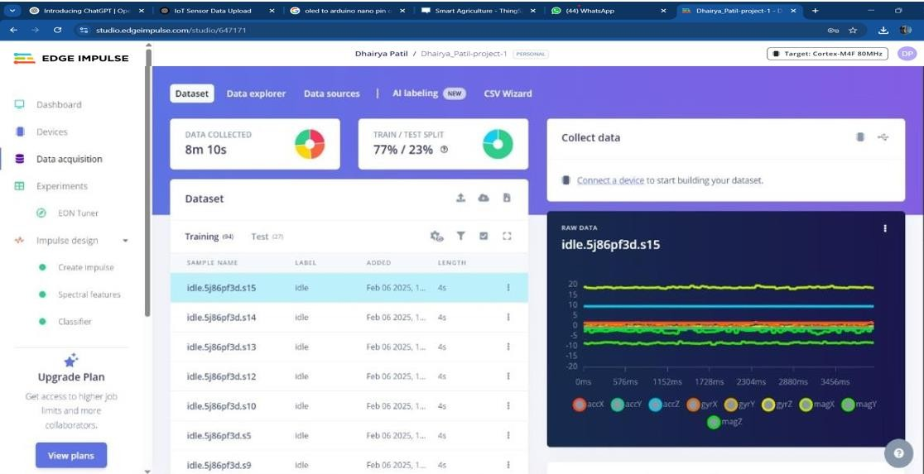

1. **Feature Extraction Image**

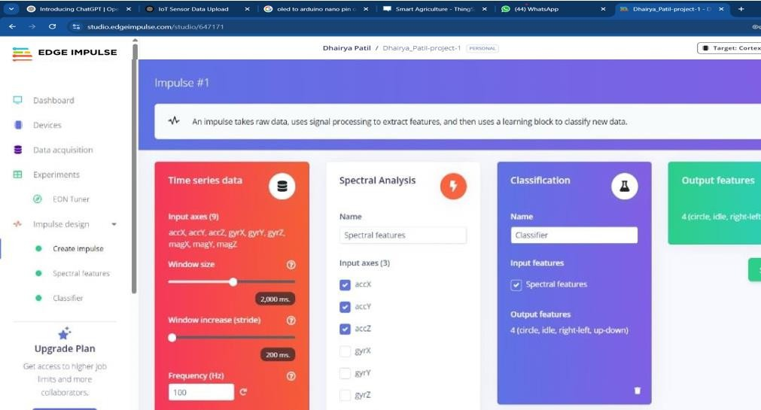

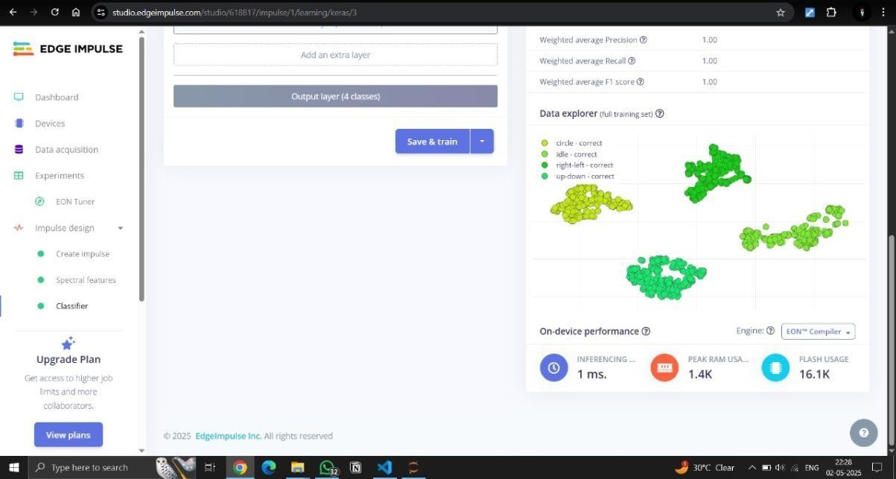

1. 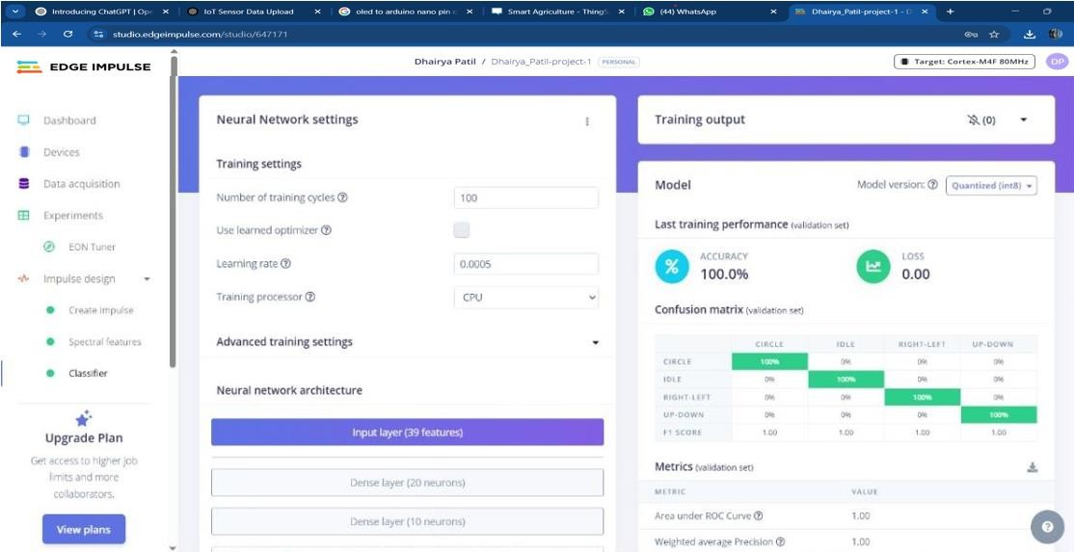**Accuracy / Loss Confusion Matrix Image**
2. Validation Result

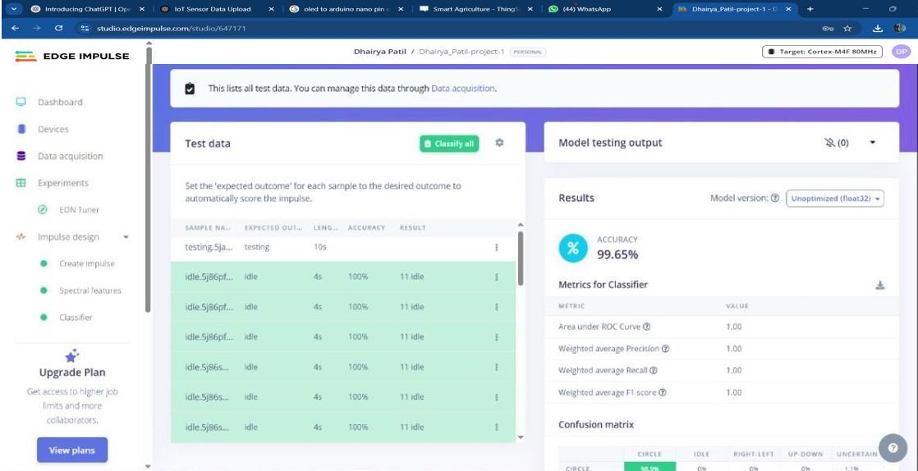

1. **Copy of the Arduino Code**

*/* Edge Impulse ingestion SDK*

* *Copyright (c) 2022 EdgeImpulse Inc.*

*\**

* *Licensed under the Apache License, Version 2.0 (the "License"); * you may not use this file except in compliance with the License.*
* *You may obtain a copy of the License at*
* [*http://www.apache.org/licenses/LICENSE-2.0*](http://www.apache.org/licenses/LICENSE-2.0) *\**
* *Unless required by applicable law or agreed to in writing, software*
* *distributed under the License is distributed on an "AS IS" BASIS,*
* *WITHOUT WARRANTIES OR CONDITIONS OF ANY KIND, either express or*

*implied. * See the License for the specific language governing permissions and*

* *limitations under the License.*

*\**

*\*/*

*/* Includes*

*\*/*

#include <r0hi7-project-1_inferencing.h>

#include <Arduino_LSM9DS1.h> *//Click here to get the library:* [*https://www.arduino.cc/reference/en/libraries/arduino_lsm9ds1/*](http://www.arduino.cc/reference/en/libraries/arduino_lsm9ds1/)

*/* Constant defines*

*\*/*

#define CONVERT_G_TO_MS2 9.80665f

*/\*\**

* *When data is collected by the Edge Impulse Arduino Nano 33 BLE Sense * firmware, it is limited to a 2G range. If the model was created with a * different sample range, modify this constant to match the input values.*
* *See https://github.com/edgeimpulse/firmware-arduino-nano-33- blesense/blob/master/src/sensors/ei_lsm9ds1.cpp*
* *for more information.*

*\*/*

#define MAX_ACCEPTED_RANGE 2.0f

*/\**

*\*\* NOTE: If you run into TFLite arena allocation issue.*

*\*\**

*\*\* This may be due to may dynamic memory fragmentation.*

*\*\* Try defining "-DEI_CLASSIFIER_ALLOCATION_STATIC" in boards.local.txt (create*

*\*\* if it doesn't exist) and copy this file to*

*\*\**

*`<ARDUINO_CORE_INSTALL_PATH>/arduino/hardware/<mbed_core>/<core_version>/`.*

*\*\**

*\*\* See*

*\*\* (https://support.arduino.cc/hc/en-us/articles/360012076960-Where-are-the-*

*installed-cores-located-)*

*\*\* to find where Arduino installs cores on your machine.*

*\*\**

*\*\* If the problem persists then there's not enough memory for this model and application.*

*\*/*

*/* Private variables*

*\*/* static bool debug_nn = false; *// Set this to true to see e.g. features generated from the raw signal* static uint32_t run_inference_every_ms = 200; static rtos::Thread inference_thread(osPriorityLow); static float buffer[EI_CLASSIFIER_DSP_INPUT_FRAME_SIZE] = { 0 }; static float inference_buffer[EI_CLASSIFIER_DSP_INPUT_FRAME_SIZE];

*/* Forward declaration */* void run_inference_background();

*/\*\**

* *@brief Arduino setup function*

*\*/*

void setup()

{

*// put your setup code here, to run once:*

Serial.begin(115200);

*// comment out the below line to cancel the wait for USB connection (needed for native USB)*

while (!Serial);

Serial.println("Edge Impulse Inferencing Demo");

if (!IMU.begin()) { ei_printf("Failed to initialize IMU!\r\n");

} else { ei_printf("IMU initialized\r\n");

} if (EI_CLASSIFIER_RAW_SAMPLES_PER_FRAME

!= 3) {

ei_printf("ERR: EI_CLASSIFIER_RAW_SAMPLES_PER_FRAME should be equal to 3 (the 3 sensor axes)\n");

return;

}

inference_thread.start(mbed::callback(&run_inference_background)); }

*/\*\**

* *@brief Return the sign of the number \**
* *@param number*
* *@return int 1 if positive (or 0) -1 if negative*

*\*/* float ei_get_sign(float number) { return (number >= 0.0) ? 1.0 : -1.0;

}

*/\*\**

* *@brief Run inferencing in the background.*

*\*/* void run_inference_background()

{

*// wait until we have a full buffer* delay((EI_CLASSIFIER_INTERVAL_MS * EI_CLASSIFIER_RAW_SAMPLE_COUNT) + 100);

*// This is a structure that smoothens the output result*

*// With the default settings 70% of readings should be the same before classifying.*

ei_classifier_smooth_t smooth; ei_classifier_smooth_init(&smooth,

10 */* no. of readings */*, 7 */* min. readings the same */*, 0.8 */* min. confidence */*, 0.3 */* max anomaly */*);

while (1)

{

*// copy the buffer* memcpy(inference_buffer, buffer,

EI_CLASSIFIER_DSP_INPUT_FRAME_SIZE * sizeof(float));

*// Turn the raw buffer in a signal which we can the classify*

signal_t signal;

int err = numpy::signal_from_buffer(inference_buffer, EI_CLASSIFIER_DSP_INPUT_FRAME_SIZE, &signal); if (err != 0) { ei_printf("Failed to create signal from buffer (%d)\n", err); return;

}

*// Run the classifier*

ei_impulse_result_t result = { 0 };

err = run_classifier(&signal, &result, debug_nn);

if (err != EI_IMPULSE_OK) { ei_printf("ERR: Failed to run classifier (%d)\n", err); return;

}

*// print the predictions*

ei_printf("Predictions "); ei_printf("(DSP: %d ms., Classification: %d ms., Anomaly: %d ms.)", result.timing.dsp, result.timing.classification, result.timing.anomaly); ei_printf(": ");

*// ei_classifier_smooth_update yields the predicted label* const char *prediction = ei_classifier_smooth_update(&smooth, &result); ei_printf("%s ", prediction); *//*

*print the cumulative results* ei_printf(" [ "); for (size_t ix = 0; ix < smooth.count_size; ix++) { ei_printf("%u", smooth.count[ix]); if (ix != smooth.count_size + 1) { ei_printf(", ");

}

else { ei_printf(" ");

} }

ei_printf("]\n");

delay(run_inference_every_ms);

}

ei_classifier_smooth_free(&smooth);

}

*/\*\**

* *@brief Get data and run inferencing*
* *@param[in] debug Get debug info if true*

*\*/*

void loop()

{ while

(1) {

*// Determine the next tick (and then sleep later)* uint64_t next_tick = micros() + (EI_CLASSIFIER_INTERVAL_MS * 1000);

*// roll the buffer -3 points so we can overwrite the last one*

numpy::roll(buffer, EI_CLASSIFIER_DSP_INPUT_FRAME_SIZE, -3);

*// read to the end of the buffer* IMU.readAcceleration( buffer[EI_CLASSIFIER_DSP_INPUT_FRAME_SIZE - 3],

buffer[EI_CLASSIFIER_DSP_INPUT_FRAME_SIZE - 2],

buffer - 1

);

for (int i = 0; i < 3; i++)

{

if (fabs(buffer[EI_CLASSIFIER_DSP_INPUT_FRAME_SIZE - 3 + i])

> MAX_ACCEPTED_RANGE) { buffer[EI_CLASSIFIER_DSP_INPUT_FRAME_SIZE - 3 + i] =

ei_get_sign(buffer[EI_CLASSIFIER_DSP_INPUT_FRAME_SIZE - 3 + i]) * MAX_ACCEPTED_RANGE;

}

}

buffer[EI_CLASSIFIER_DSP_INPUT_FRAME_SIZE - 3] *= CONVERT_G_TO_MS2; buffer[EI_CLASSIFIER_DSP_INPUT_FRAME_SIZE - 2]

*= CONVERT_G_TO_MS2; buffer[EI_CLASSIFIER_DSP_INPUT_FRAME_SIZE - 1] *= CONVERT_G_TO_MS2;

*// and wait for next tick* uint64_t time_to_wait = next_tick - micros(); delay((int)floor((float)time_to_wait / 1000.0f)); delayMicroseconds(time_to_wait % 1000);

}

}

#if !defined(EI_CLASSIFIER_SENSOR) || EI_CLASSIFIER_SENSOR !=

EI_CLASSIFIER_SENSOR_ACCELEROMETER

#error "Invalid model for current sensor" #endif

1. **Output**

Edge Impulse Inferencing Demo IMU initialized

Predictions (DSP: 5 ms., Classification: 10 ms., Anomaly: 3 ms.): Idle [ 9, 0, 0, 1 ]

Predictions (DSP: 5 ms., Classification: 9 ms., Anomaly: 2 ms.): Idle [ 10, 0, 0, 0 ]

Predictions (DSP: 5 ms., Classification: 11 ms., Anomaly: 3 ms.): Left Right [ 0, 0, 9, 1 ]

Predictions (DSP: 6 ms., Classification: 10 ms., Anomaly: 2 ms.): Left Right [ 0, 0, 10, 0 ]

Predictions (DSP: 5 ms., Classification: 11 ms., Anomaly: 3 ms.): Circular [ 7, 2, 0, 1 ]

Predictions (DSP: 5 ms., Classification: 10 ms., Anomaly: 2 ms.): Circular [ 8, 1, 0, 1 ]

Predictions (DSP: 6 ms., Classification: 9 ms., Anomaly: 3 ms.): Up Down [ 0, 1, 1, 8 ]

Predictions (DSP: 5 ms., Classification: 11 ms., Anomaly: 2 ms.): Up Down [ 0, 1, 1, 8 ]

Predictions (DSP: 5 ms., Classification: 10 ms., Anomaly: 3 ms.): Idle [ 9, 0, 1, 0 ]

Predictions (DSP: 5 ms., Classification: 10 ms., Anomaly: 2 ms.): Idle [ 10, 0, 0, 0 ]